**INTERIM PROJECT REPORT**

**AZURE DATA FACTORY CAPSTONE -COVID USE CASE**

**PREPARED BY:**

**ASSOCIATE ID: 2381869**

**ASSOCIATE NAME: ALAN BENO**

**GUIDED BY:**

**Trainer Coach**

**Karthick Selvam Harismitha Srinivasan**

**Contractor Jr.Executive-HR**

**CPO L&D GenC Training CPO L&D GenC Training**

**Table of Contents**

**1. Introduction**

* **1.1 Overview**
* **1.2 Objectives**

**2. Requirements**

* **2.1 Prerequisites**
* **2.2 Azure Resources**

**3. Process**

**3.1 Setting Up Azure Resources**

* **3.1.1 Creating Azure Data Lake Storage Gen2**
* **3.1.2 Creating a Container and Uploading CSV Files**
* **3.1.3 Setting Up Azure Synapse Analytics**
* **3.1.4 Creating a Dedicated SQL Pool**
* **3.1.5 Creating an Azure Data Factory**

**3.2 Configuring Azure Data Factory**

* **3.2.1 Creating Linked Services**
* **3.2.2 Configuring Datasets**

**3.3 Implementing Data Processing in Synapse**

* **3.3.1 Creating a SQL Configuration Table**
* **3.3.2 Implementing a Stored Procedure**

**3.4 Building the Data Pipeline**

* **3.4.1 Creating the CopyCovidData-ADLS-SQL Pipeline**
* **3.4.2 Implementing Lookup Activity for Source Data**
* **3.4.3 Creating ForEach Activity to Process Multiple Files**
* **3.4.4 Configuring Copy Data Activity for Bulk Insert**
* **3.4.5 Configuring Data Flow For Transformation**

**3.5 Data Warehouse and Transformation**

* **3.5.1 Running SQL Queries for Data Validation**

**4. Key Accomplishments**

**5. Project Summary**

**1. Introduction**

**1.1 Overview**

This capstone project demonstrates how to build a real-world data pipeline using Azure Data Factory (ADF) to analyze Covid trends across different regions. The project involves:

* Ingesting data from CSV files stored in Azure Data Lake Storage Gen2 (ADLS).
* Transforming data using Azure Data Factory and Data Flows.
* Loading data into Azure Synapse Analytics for analysis.
* Performing SQL queries to validate the dataset and analyze Covid trends.

**1.2 Objectives**

* Automate the process of ingesting, transforming, and analyzing Covid data.
* Utilize Azure cloud services to streamline data processing.
* Gain hands-on experience with Azure Data Factory, Synapse Analytics, and SQL.

**2. Project Requirements**

**2.1 Prerequisites**

* Basic knowledge of Azure services.
* Understanding of SQL and ETL pipelines is helpful but not mandatory.

**2.2 Azure Resources Used**

|  |  |
| --- | --- |
| Azure Service | Resource Name |
| Resource Group | rg-azuser2682_mml.local-8aeC9 |
| Azure Data Lake Storage Gen2 | covidadls2001 |
| ADLS Container | covid |
| Azure Synapse Analytics | covid-synapse-workspace2001 |
| Azure Data Factory | CovidUseCaseADF2001 |

**3. Process**

**3.1 Setting Up Azure Resources**

* **3.1.1 Creating Azure Data Lake Storage Gen2**
  + Storage Account Name: covidadls2001
  + Region: West US
  + Replication Type: Locally Redundant Storage (LRS)
  + Enabled Hierarchical Namespace

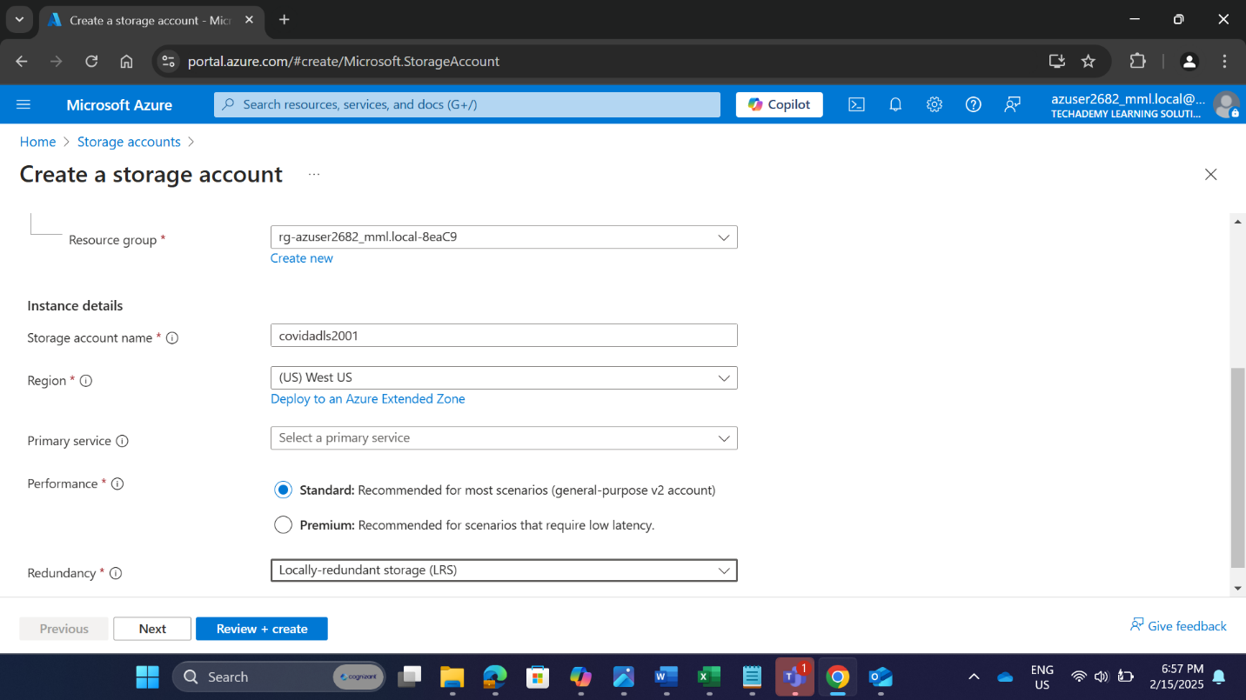

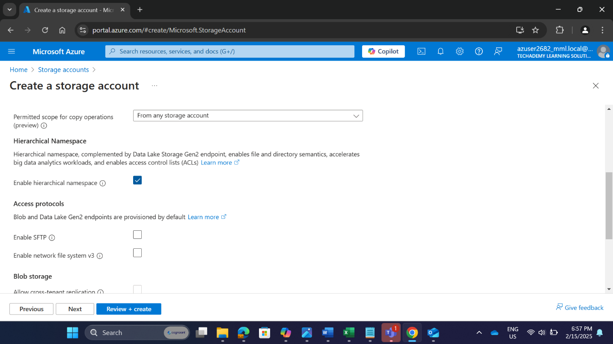

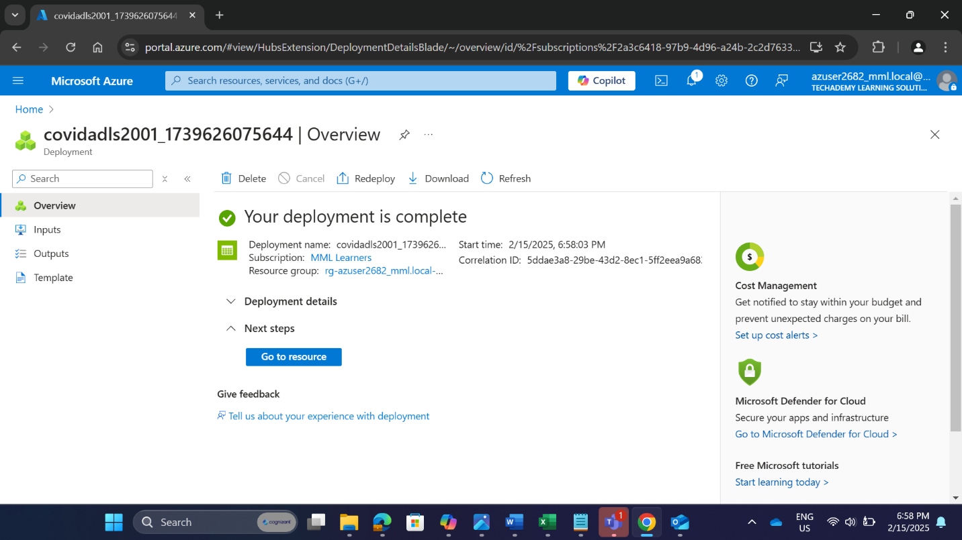

Successfully Created Storage Account

* **3.1.2 Creating a Container and Uploading CSV Files**
  + Container Name: covid
  + Inside Folder: datasource
  + Uploaded Files:
    - case_deaths_uk_ind_only.csv
    - cases_deaths.csv
    - country_response.csv
    - hospital_admissions.csv
    - testing.csv

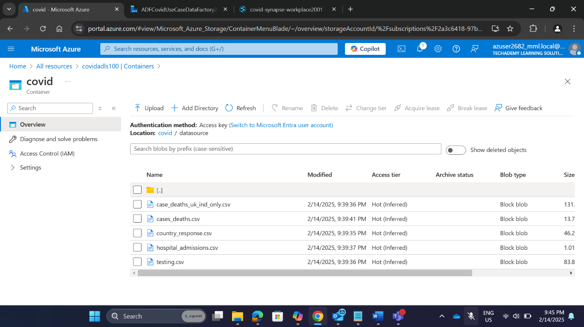

* **3.1.3 Setting Up Azure Synapse Analytics**
  + Workspace Name: covid-synapse-workspace2001
  + Region: West US
  + Linked to Storage Account: covidadls2001
  + File System Name: covid
  + SQL Server Admin Login: alan

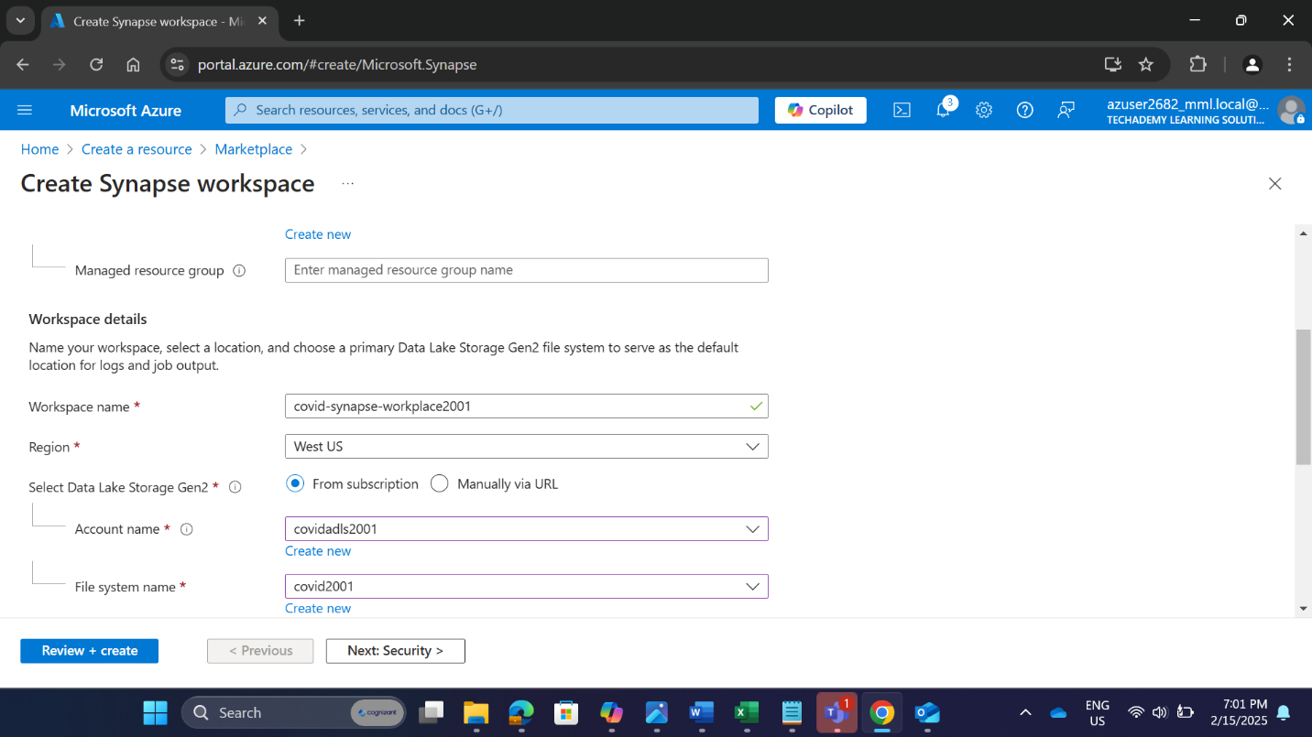

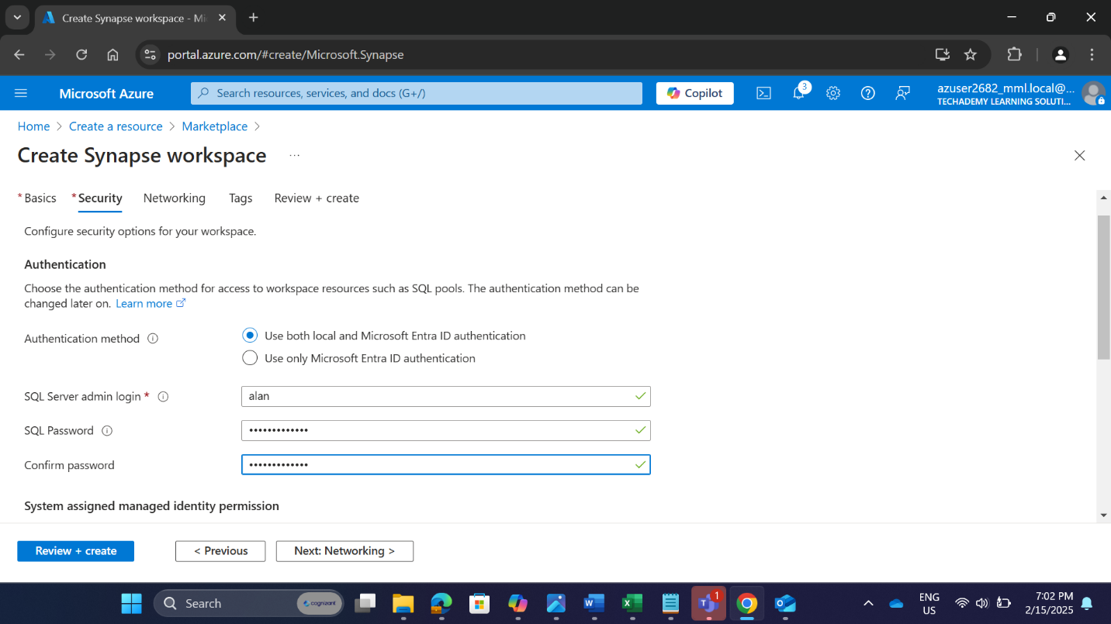

* **3.1.4 Creating a Dedicated SQL Pool**
  + SQL Pool Name: covidpool2001
  + Performance Level: DW100C

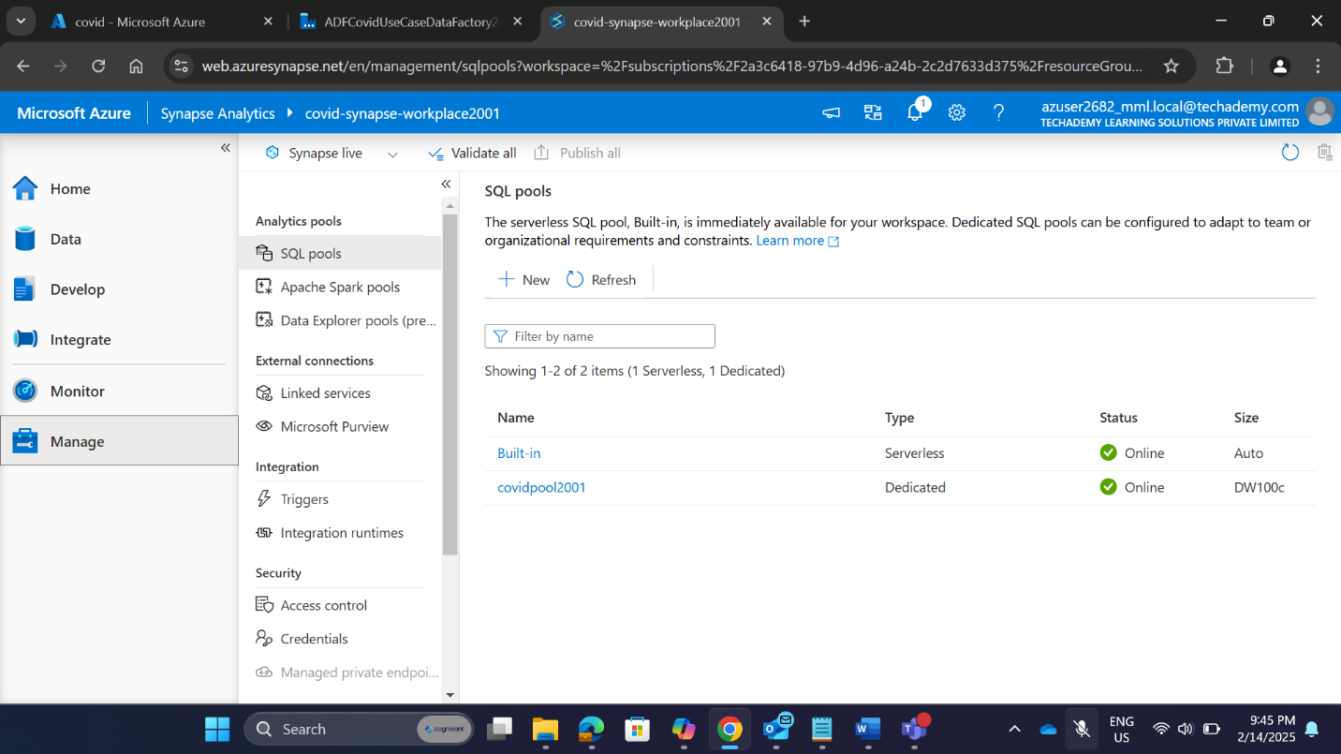

* **3.1.5 Creating an Azure Data Factory**
  + ADF Name: CovidUseCaseADF
  + Region: West US
  + Version: V2

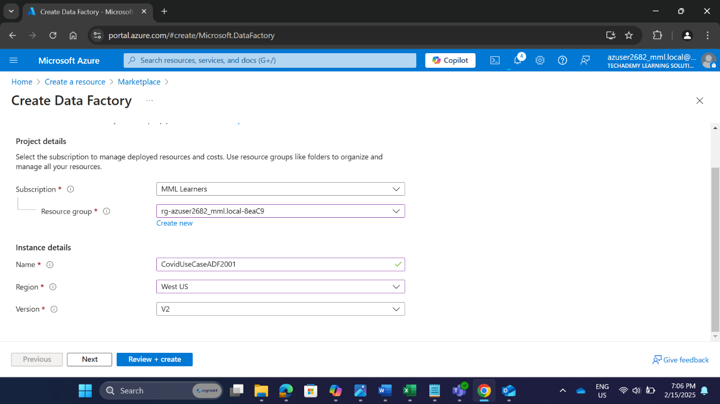

**3.2 Configuring Azure Data Factory**

* **3.2.1 Creating Linked Services**
* **Linked Service 1 (Azure Data Lake Storage Gen2)**
  + Name: LS_adls2001
  + Data Store: Azure Data Lake Storage Gen2
  + Storage Account Name: covidadls2001
  + Connection Status: Successful
* **Linked Service 2 (Azure Synapse Analytics)**
  + Name: lLS_dw2001
  + Data Store: Azure Synapse Analytics
  + Server Name: covid-synapse-workspace2003
  + Database Name: covidpool2001
  + Connection Status: Successful

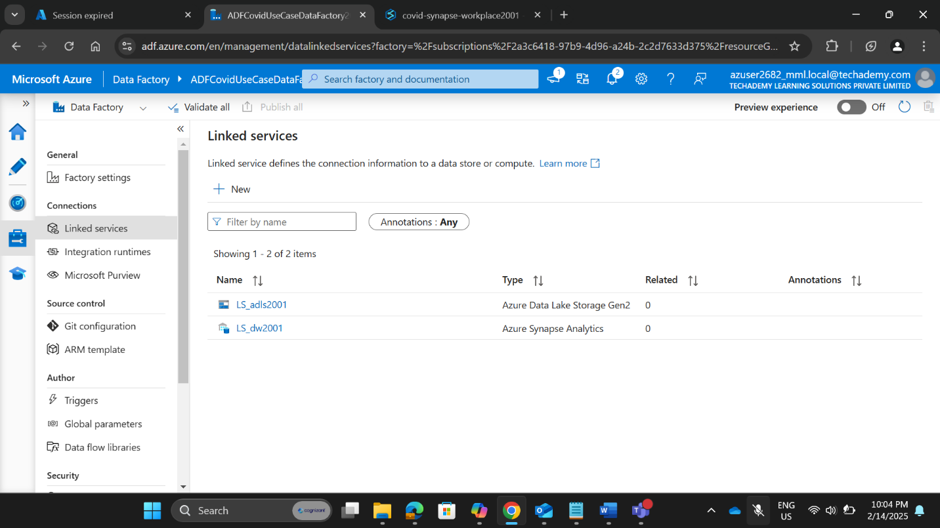

* **3.2.2 Configuring Datasets**

**Dataset 1 (Azure Data Lake Storage - CSV File)**

* + Name: DS_adls
  + Linked Service: LS_adls
  + File Path: covid/datasource
  + File Type: Delimited Text (CSV)

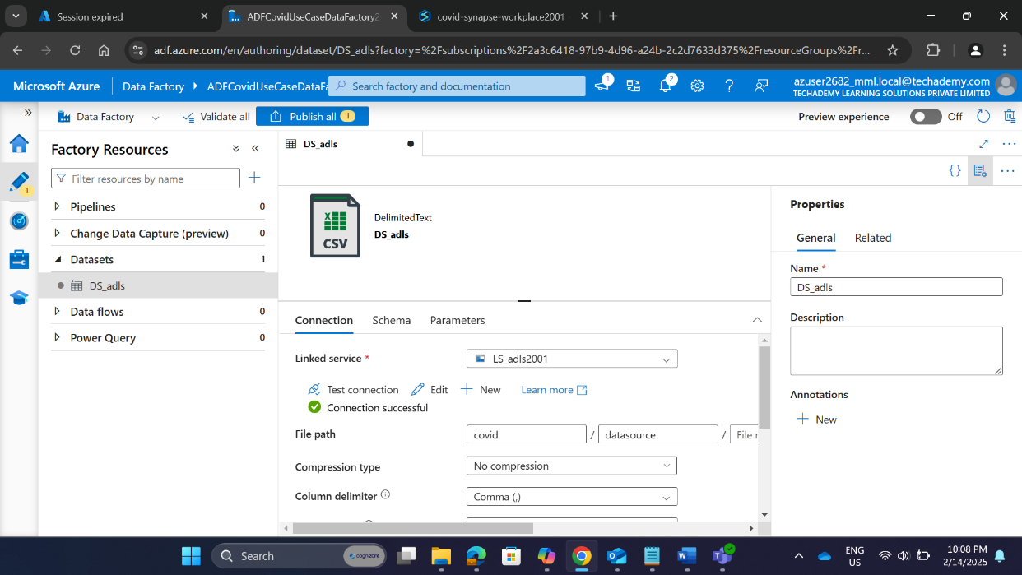

**Dataset 2 (Azure Synapse Analytics - No Table Selected)**

* + Name: DS_dw
  + Linked Service: LS_dw
  + Table Name: Not Selected

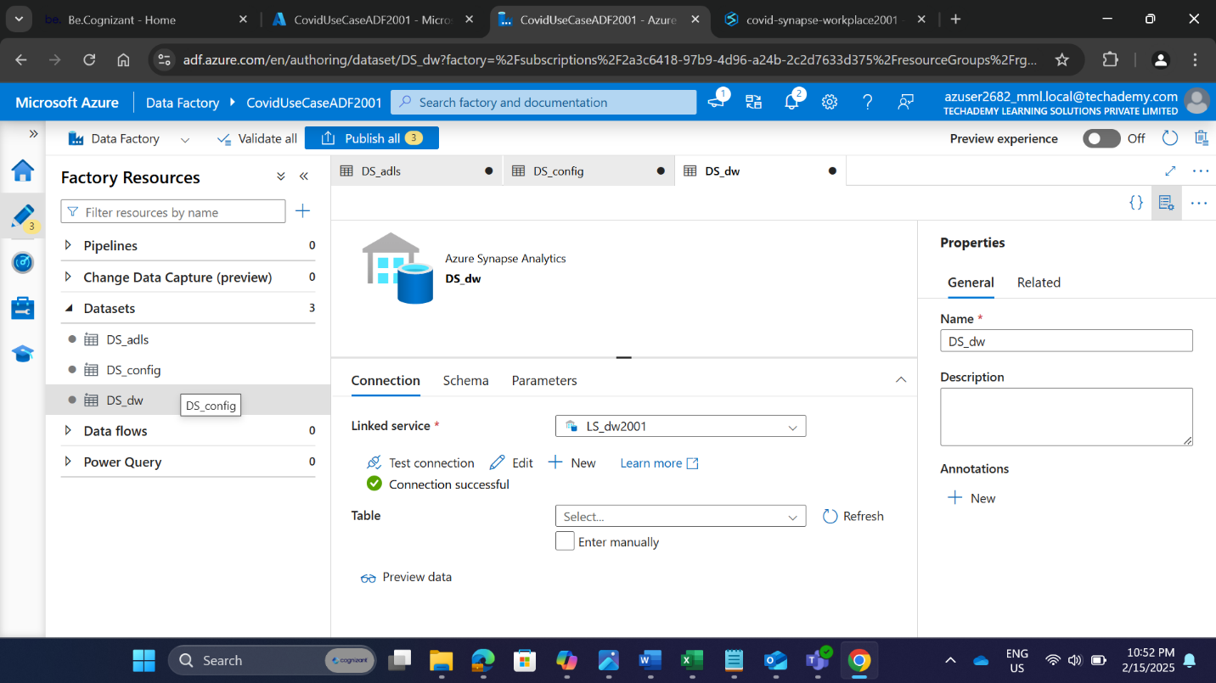

**Dataset 3 (Configuration Table from Synapse Analytics)**

* + Name: DS_config
  + Linked Service: LS_DW
  + Table Name: dbo.config_srcfileNames

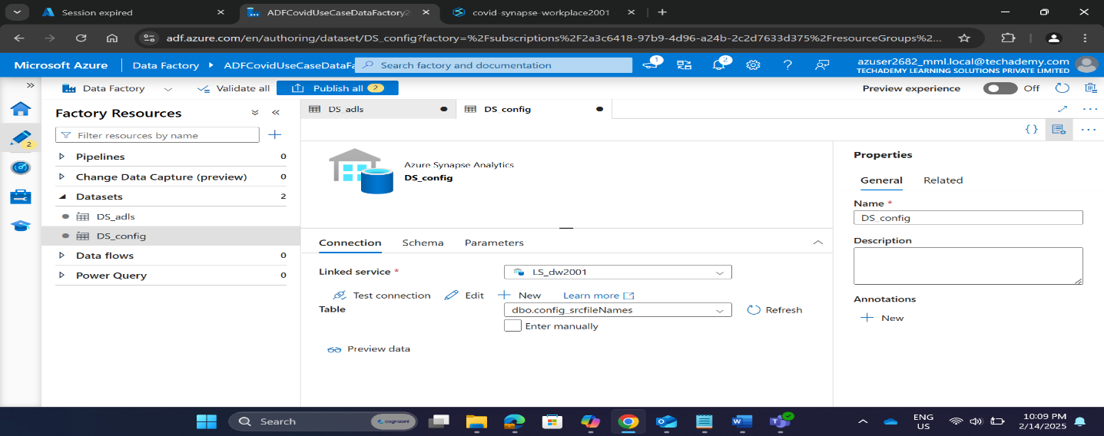

* 1. **Implementing Data Processing in Synapse**
* 3.3.1 Creating a SQL Configuration Table
  + SQL Script Name: configdataset
  + Table Name: dbo.config_srcfileNames
  + Columns:
    - FileName (VARCHAR(255))

**SQL Script to Create Configuration Table**

|  |
| --- |
| CREATE TABLE dbo.config_srcfileNames(      FILENAME VARCHAR(255)  ); |

**Insert CSV File Names**

|  |
| --- |
| INSERT INTO dbo.config_srcfileNames (FileName) VALUES('case_deaths_uk_ind_only.csv');  INSERT INTO dbo.config_srcfileNames (FILENAME) VALUES('cases_deaths.csv');  INSERT INTO dbo.config_srcfileNames (FILENAME) VALUES('country_response.csv');  INSERT INTO dbo.config_srcfileNames (FILENAME) VALUES('hospital_admissions.csv');  INSERT INTO dbo.config_srcfileNames (FILENAME) VALUES('testing.csv'); |

**Retrieve The Table**

|  |
| --- |
| select * From dbo.config_srcfileNames; |

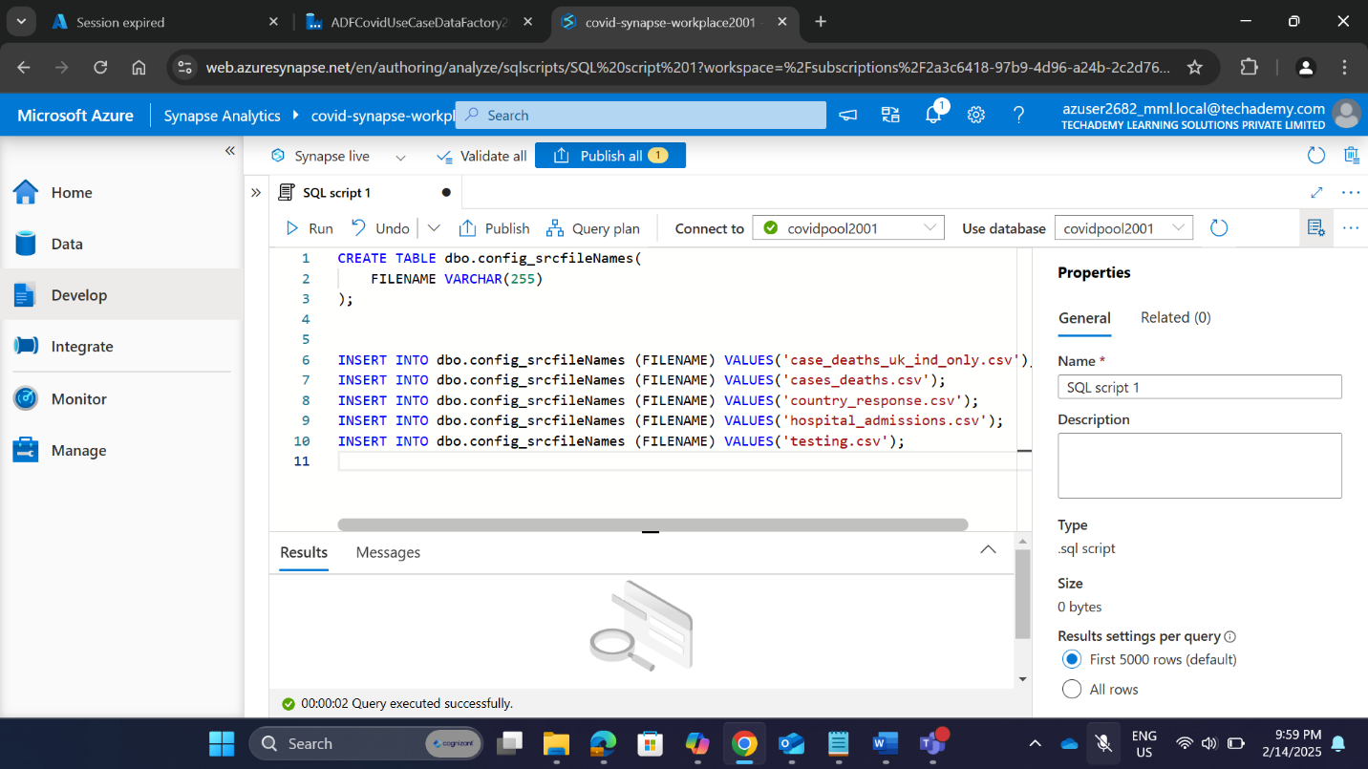

* **Recorded tables :** 
  + case_deaths_uk_ind_only.csv
  + cases_deaths.csv
  + country_response.csv
  + hospital_admissions.csv
  + testing.csv

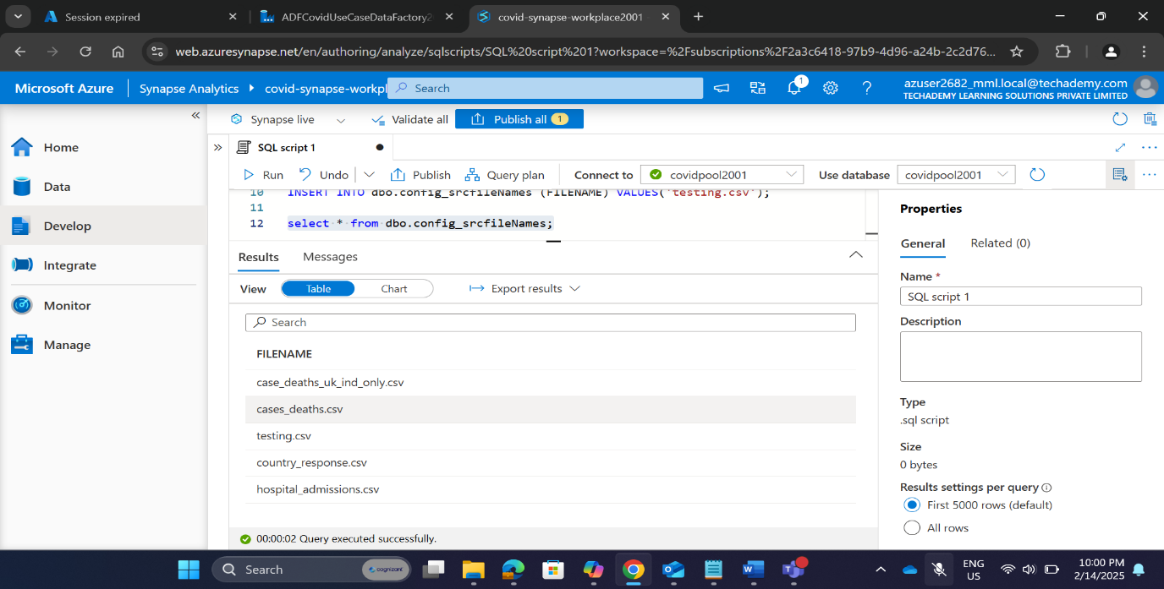

* **3.3.2 Implementing a Stored Procedure**
  + Implementing Stored Procedure to Retrieve File Names.

|  |
| --- |
| CREATE PROCEDURE sp_GetConfigSrcFileNames AS BEGIN     SELECT FILENAME FROM dbo.config_srcfileNames; END |

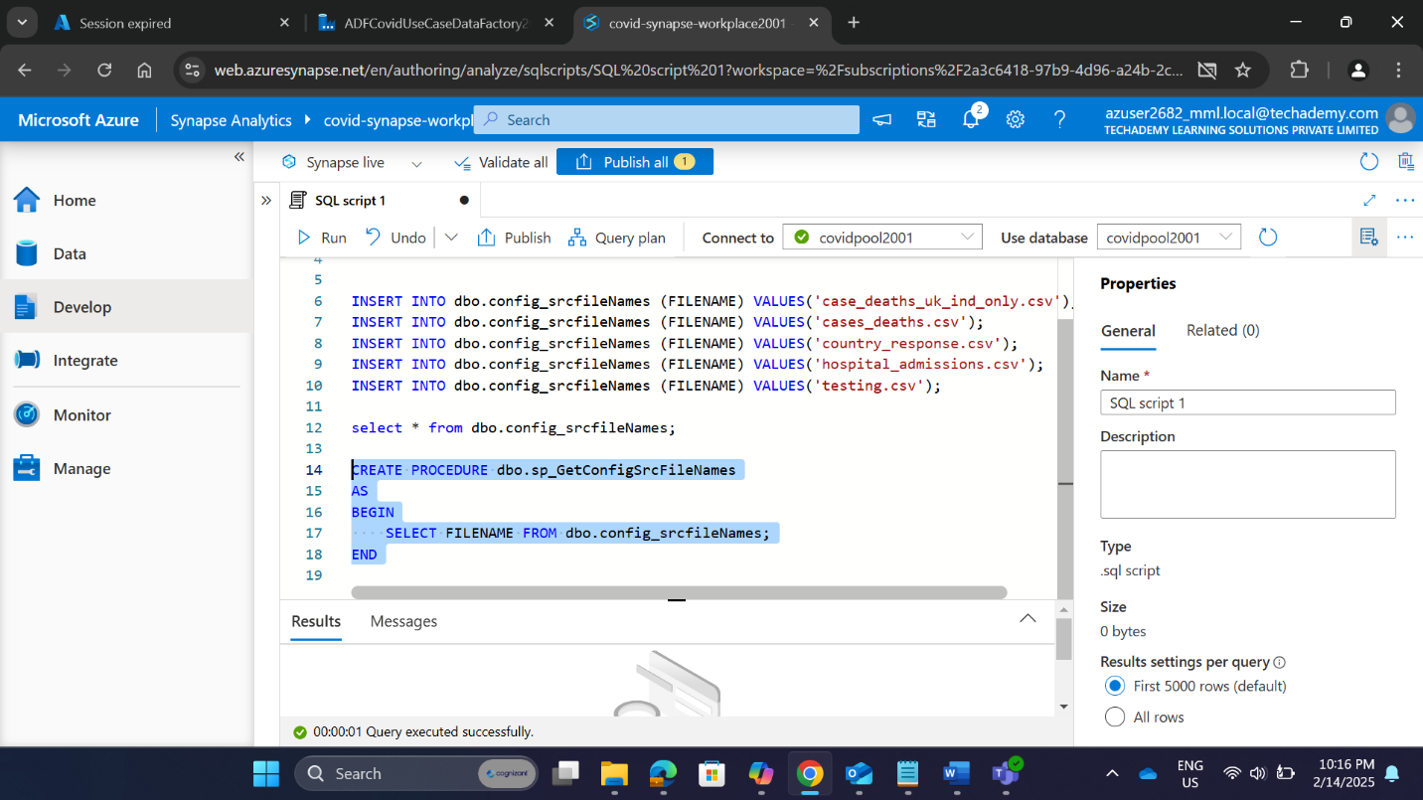

* 1. **Building the Data Pipeline**
* **3.4.1 Creating the CopyCovidData-ADLS-SQL Pipeline**
  + Pipeline Name: CopyCovidData-ADLS-SQL
  + Created in: ADF
  + Purpose: Transfers data from Azure Data Lake Storage (ADLS) to Synapse Analytics

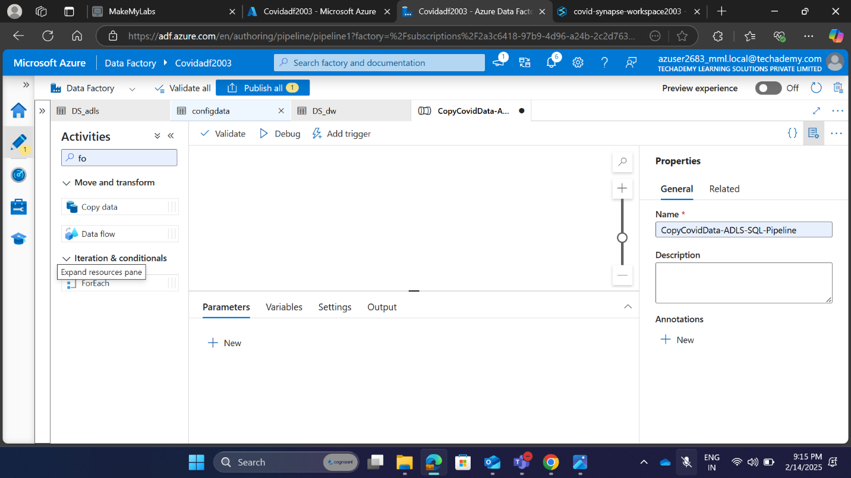

* **3.4.2 Implementing Lookup Activity for Source Data**
  + Lookup Activity Name: Lookup Activity
  + Used Query: Stored Procedure
  + Source Dataset: configdata (linked to dbo.config_srcfileNames table)
  + Stored Procedure Name: [dbo]. [sp_GetConfigSrcFileNames]
  + Validation: Successful
  + Debug Status : Successful

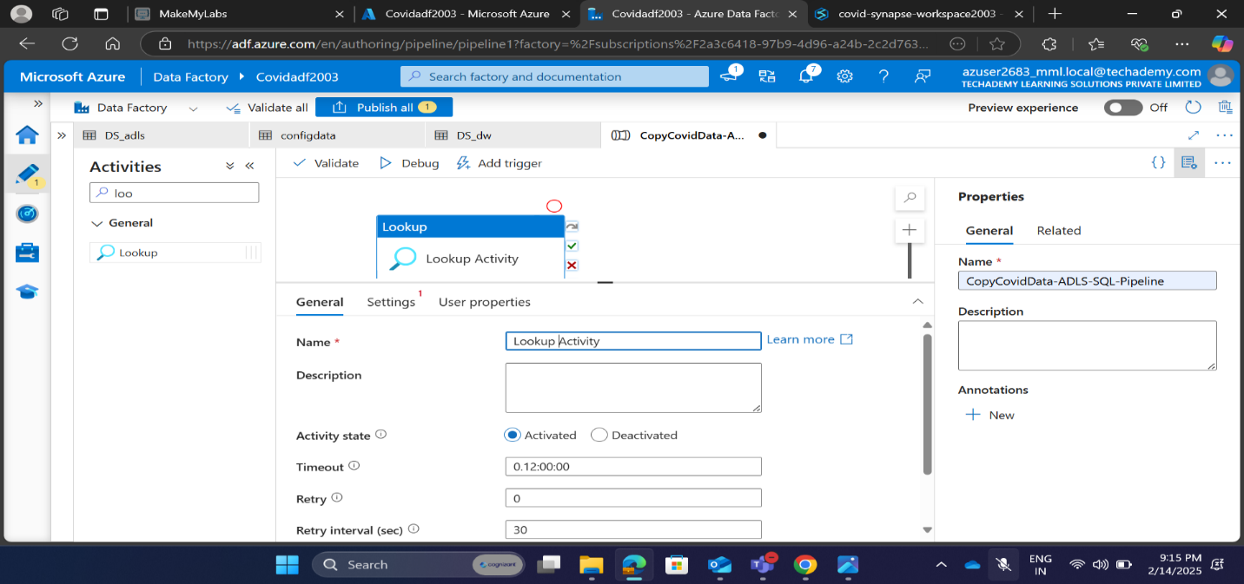

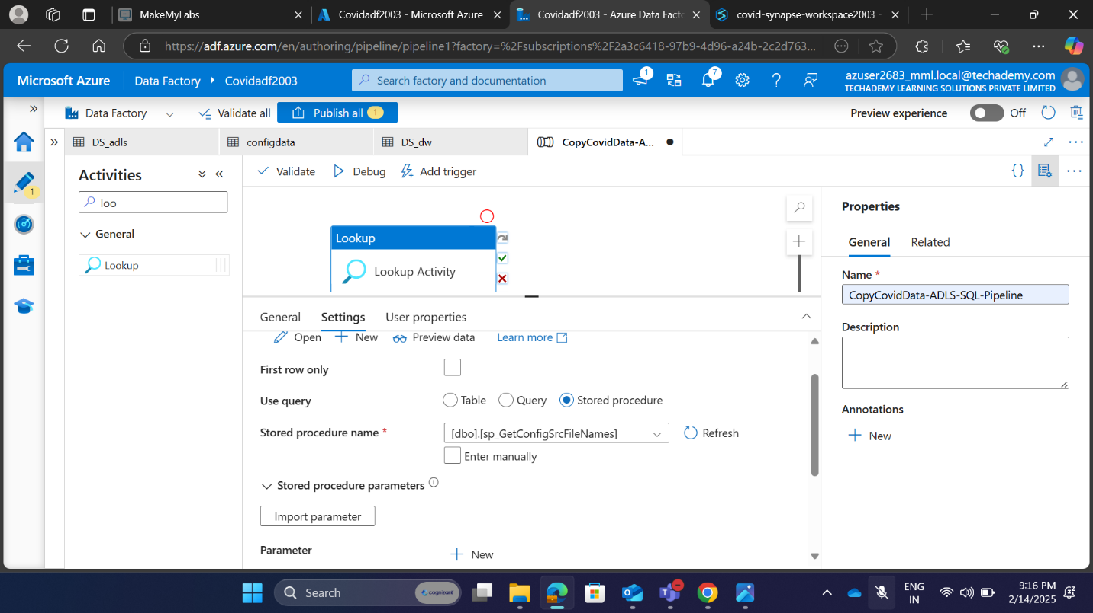

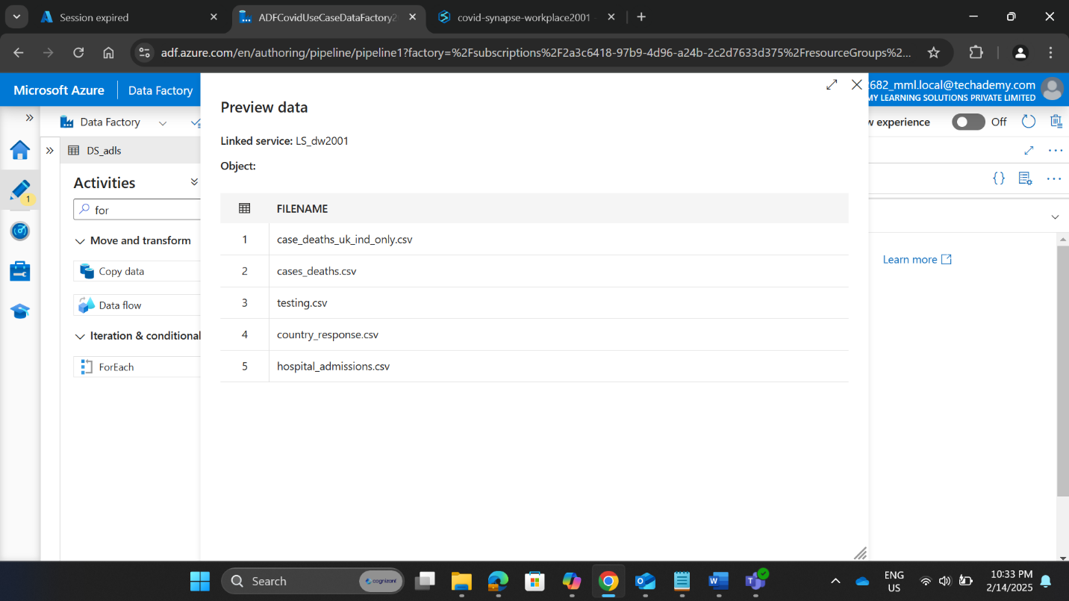

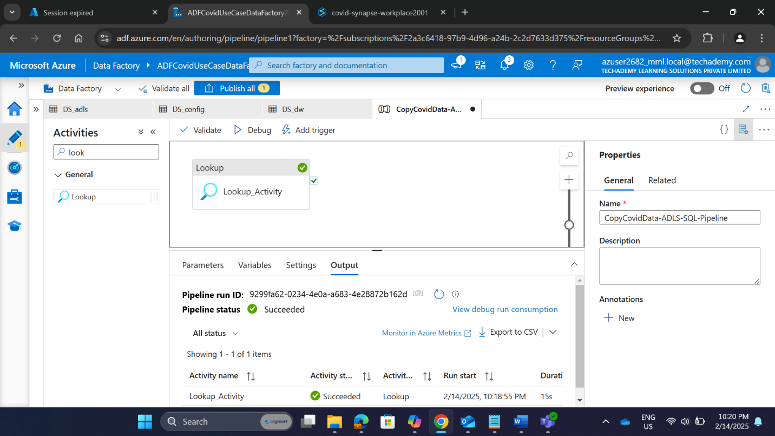

* **3.4.3 Creating ForEach Activity to Process Multiple Files**
  + Activity Name: ForEach1
  + Settings:
* Items: @activity('LookupActivity'). output.value (Give this in dynamic Content in expression builder)
* Connected To: Lookup Activity
  + Activity Inside ForEach: Copydata1
  + Validation : Successful
  + Debug Status: Successful

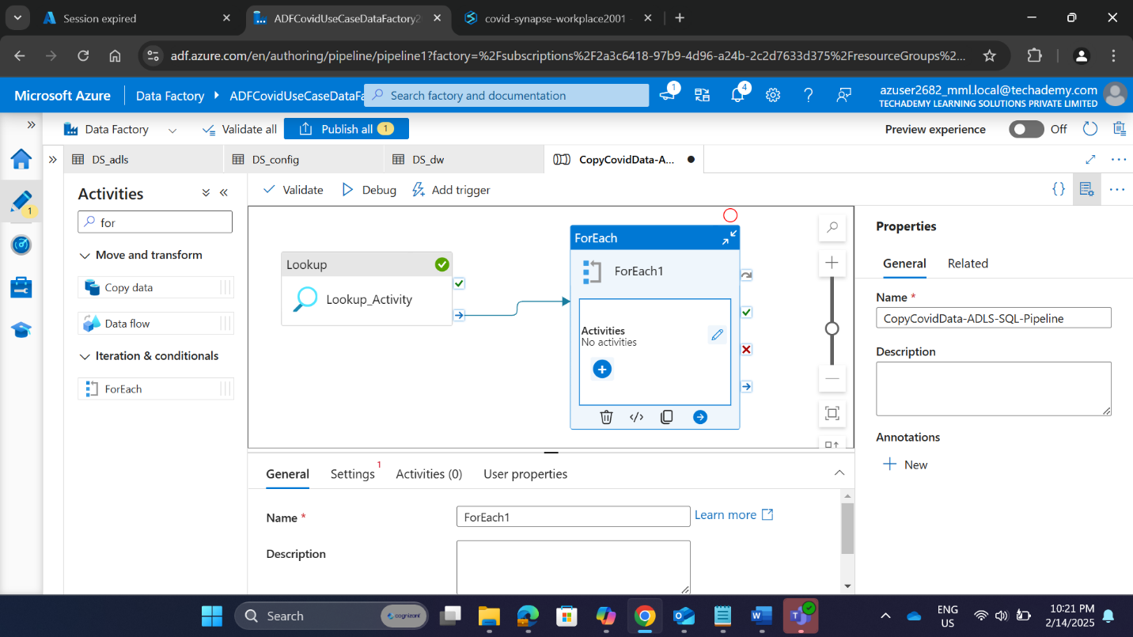

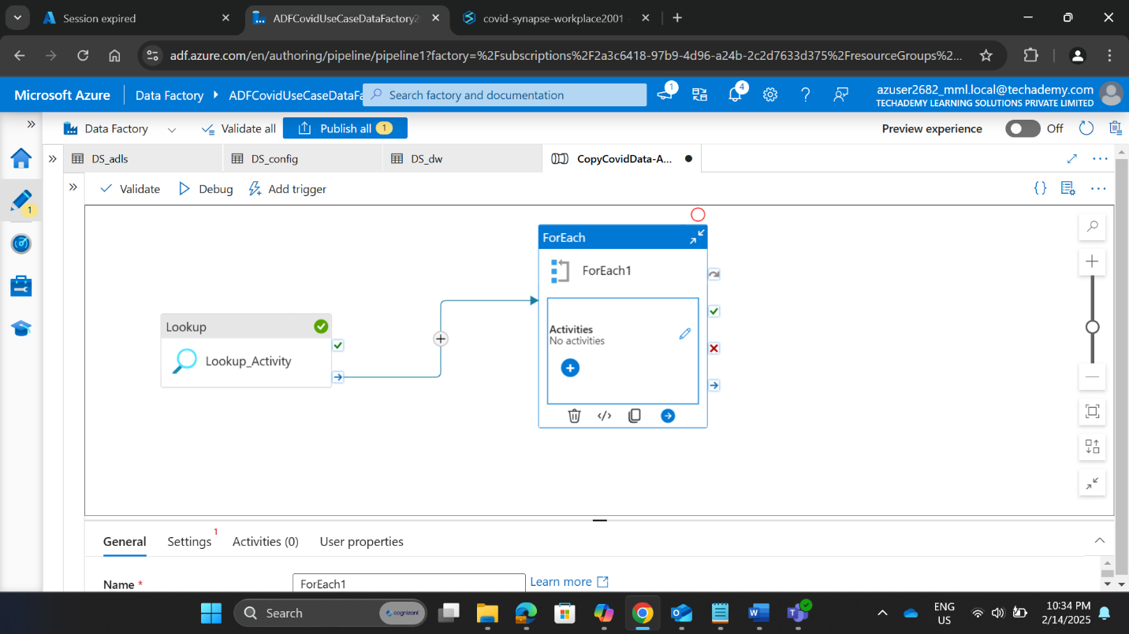

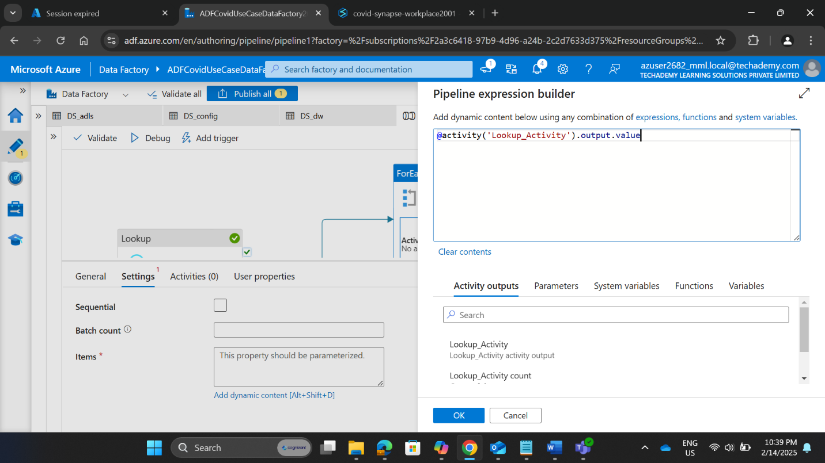

* **3.4.4 Configuring Copy Data Activity for Bulk Insert**
  + Activity Name: Copydata1
  + Source Dataset: DS_adls
  + Sink Dataset:DS_dw
  + Wildcard File Path: @item().FileName (Pipeline expression builder)
  + Copy Method: Bulk Insert
  + Table: Auto Create Table
  + Validation & Debug Status: Successful

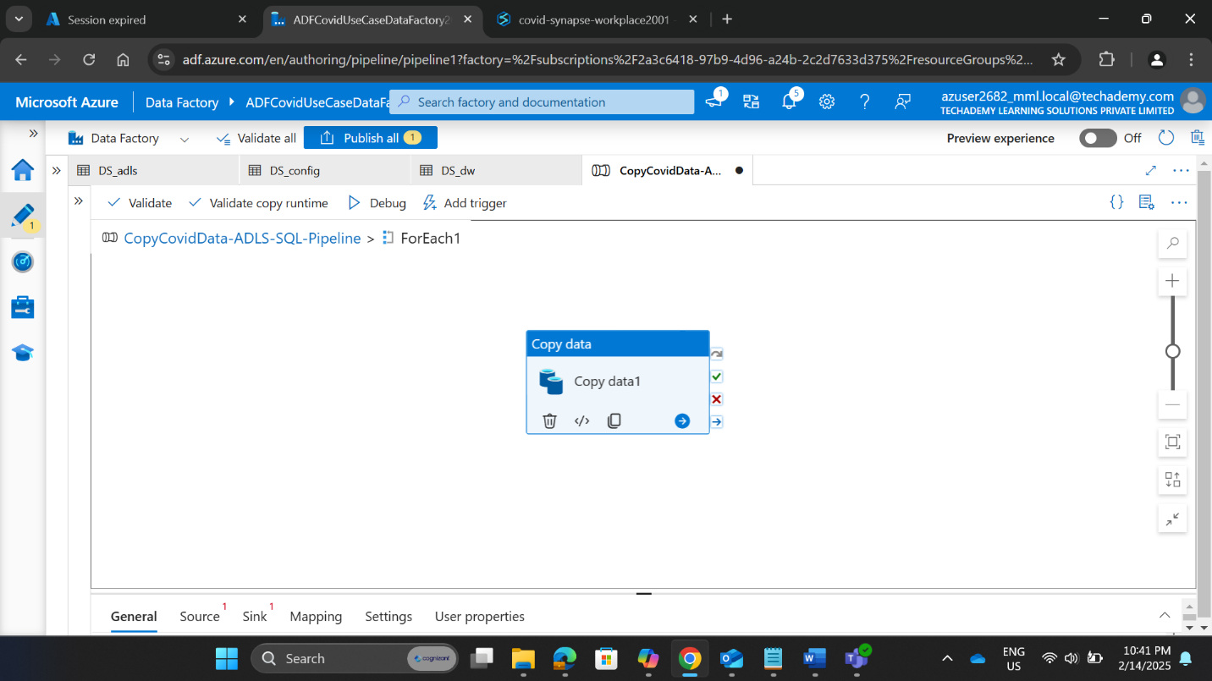

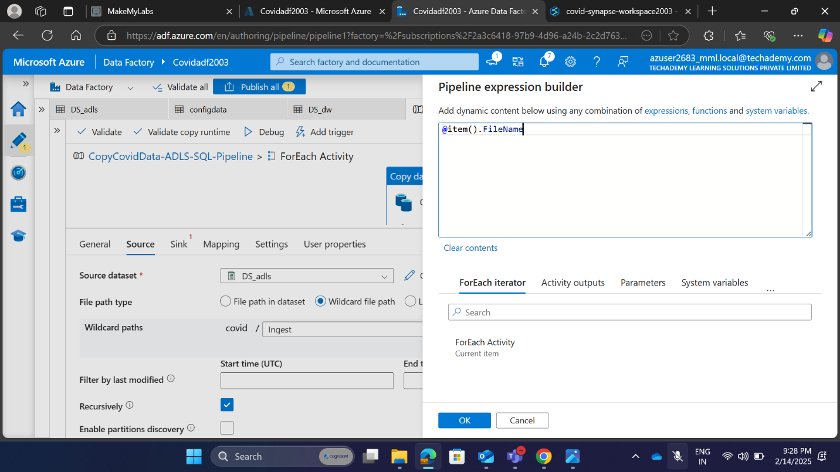

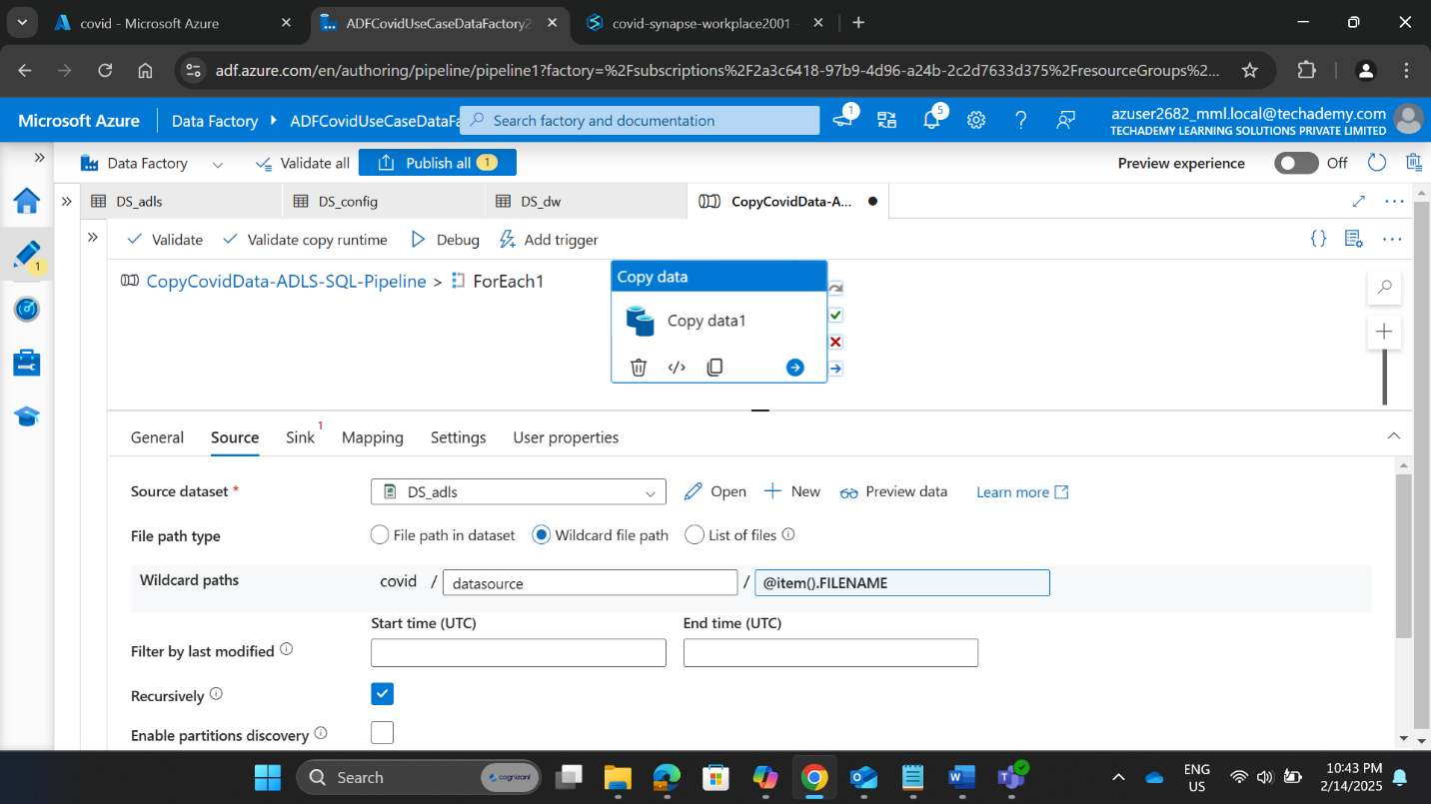

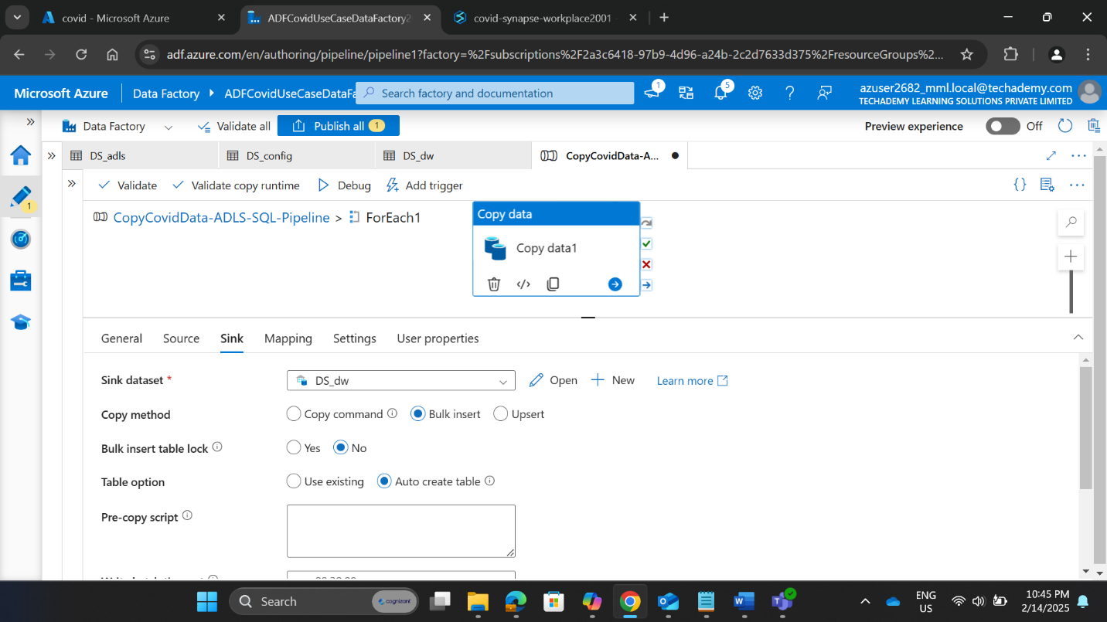

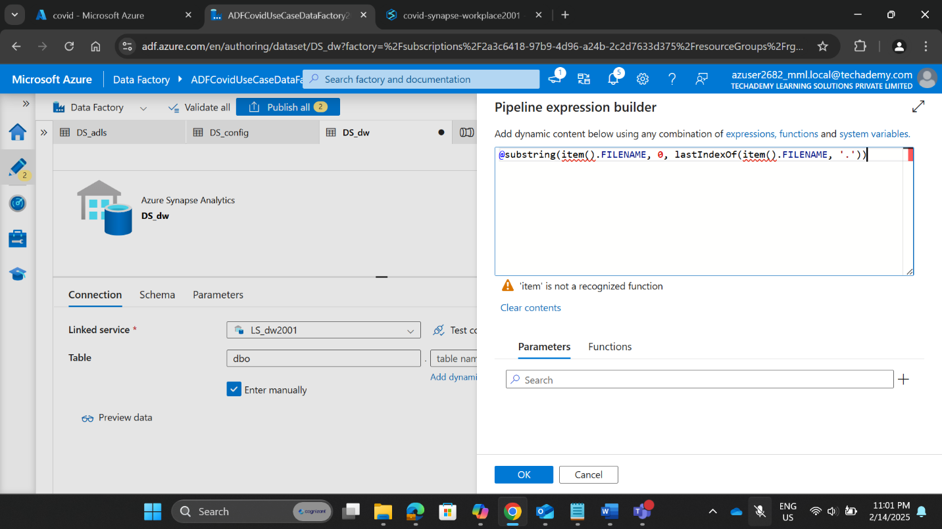

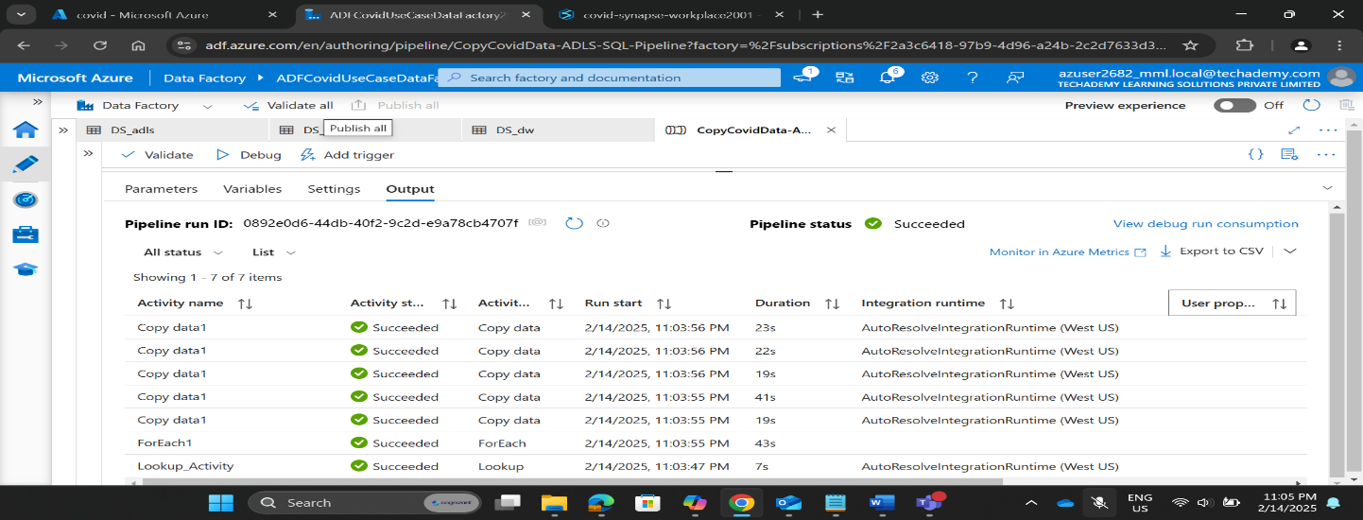

**3.4.5 Configuring Data Flow For Transformation**

The ForEach Activity was validated, and a Data Flow was implemented to process case_deaths.csv through aggregation, ranking, and storage.

Steps in Data Flow:

Source Transformation:

* Source Name : source1
* Dataset: DS_adls
* File_Filter: testing.csv

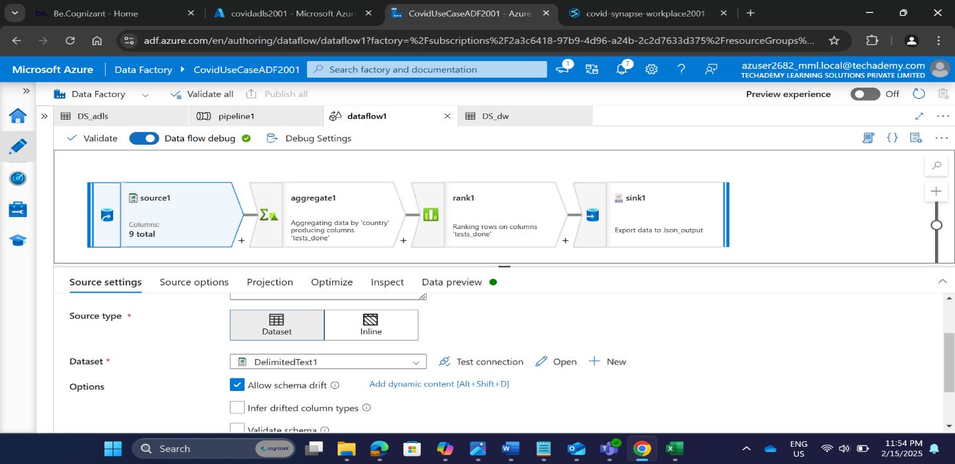

**Aggregate Transformation:**

* Name: aggregate1
* Incoming Stream: source1
* Group By Column: country
* Aggregate Column: tests_done
* Aggregation Expression: min(tests_done)

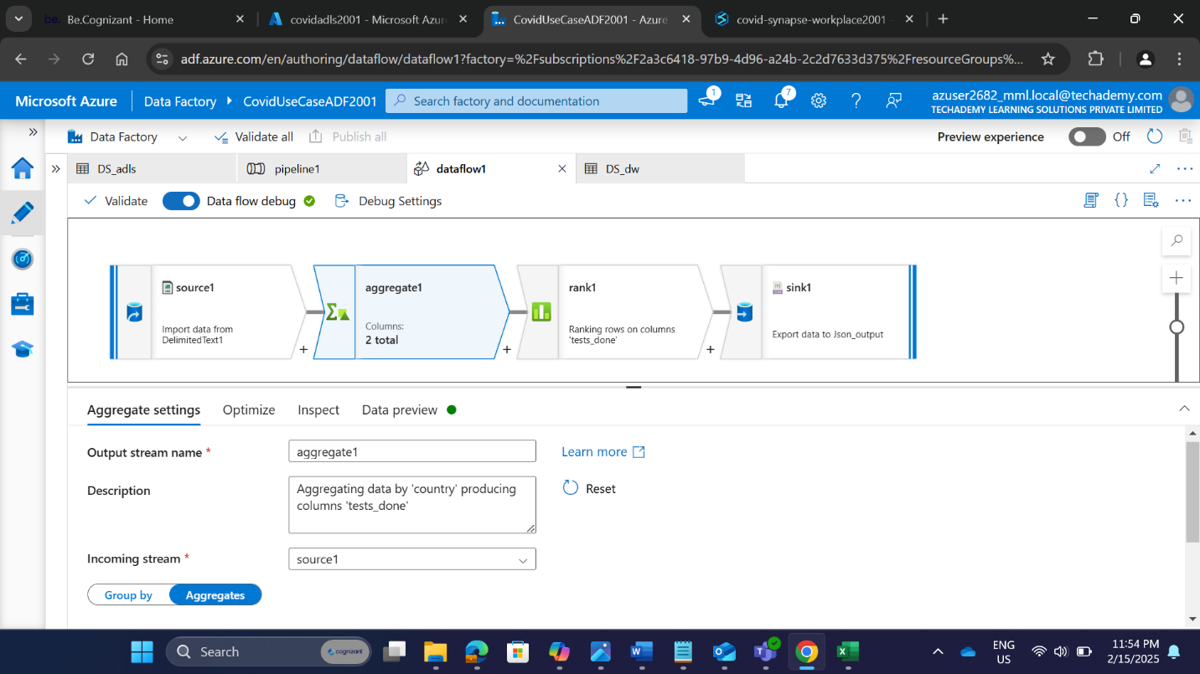

**Rank Transformation:**

* Name: rank1
* Incoming Stream: aggregate1
* Ranking Column: tests_done
* Sort Condition: Ascending Order
* Purpose: Ranks the countries based on tests_done

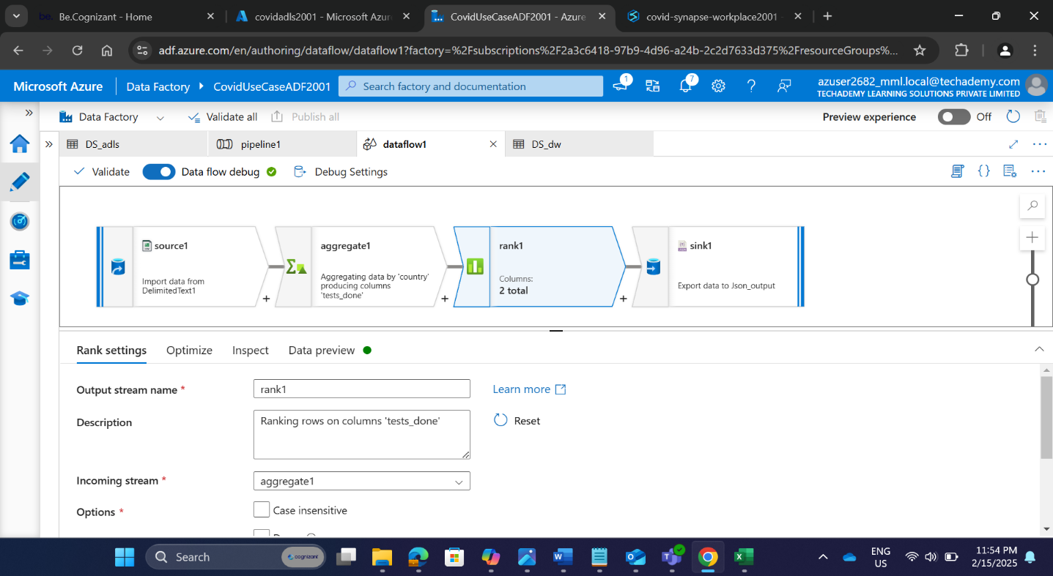

**Sink Transformation (Storing the Output):**

* Sink Type: Dataset
* Dataset Name: DS_transformation_json
* Container Name: transform (Created in Azure Data Lake Storage Gen2)
* Output Format: JSON

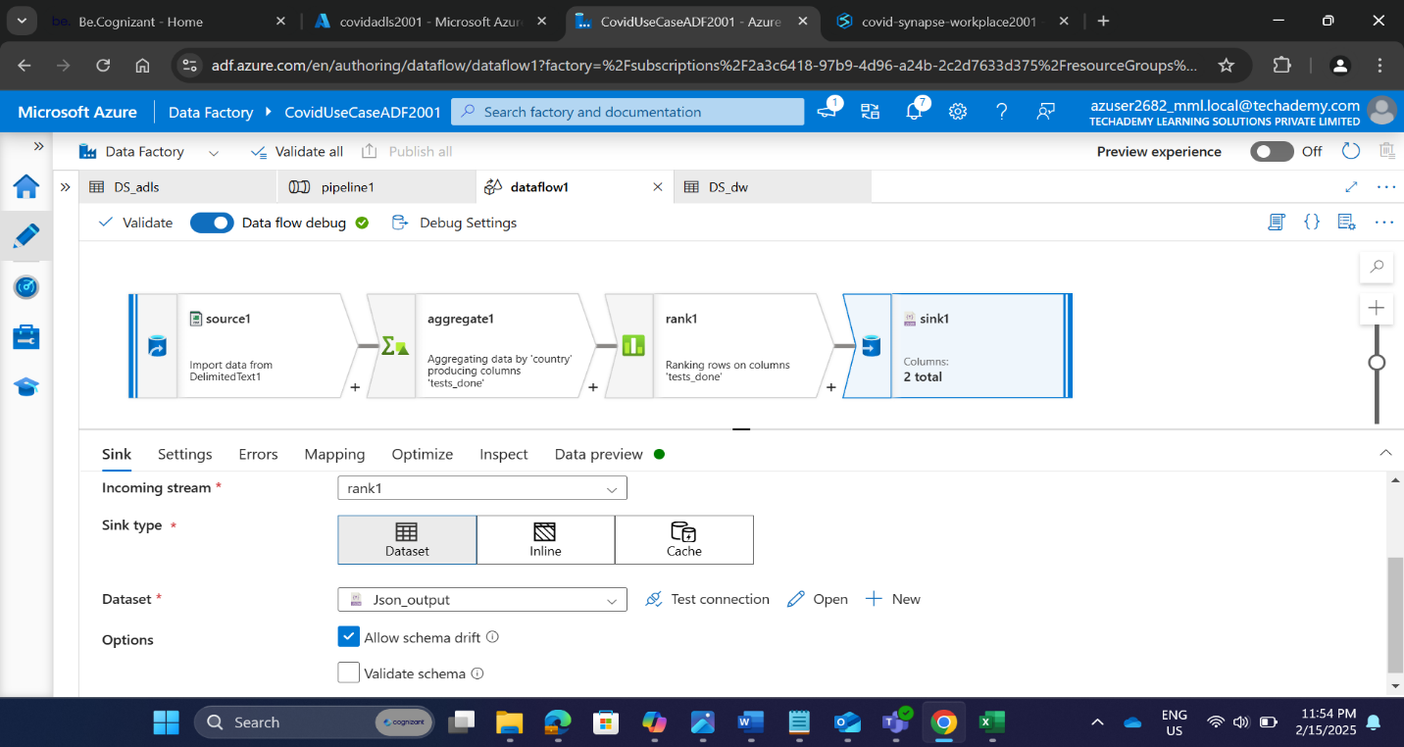

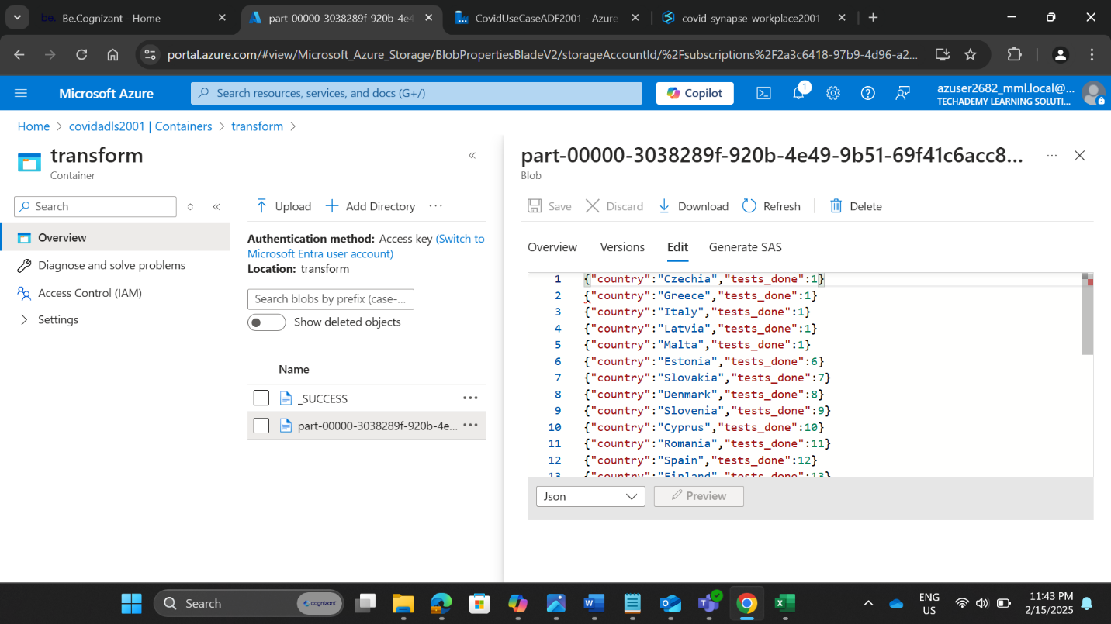

**OVERALL DATA FLOW**

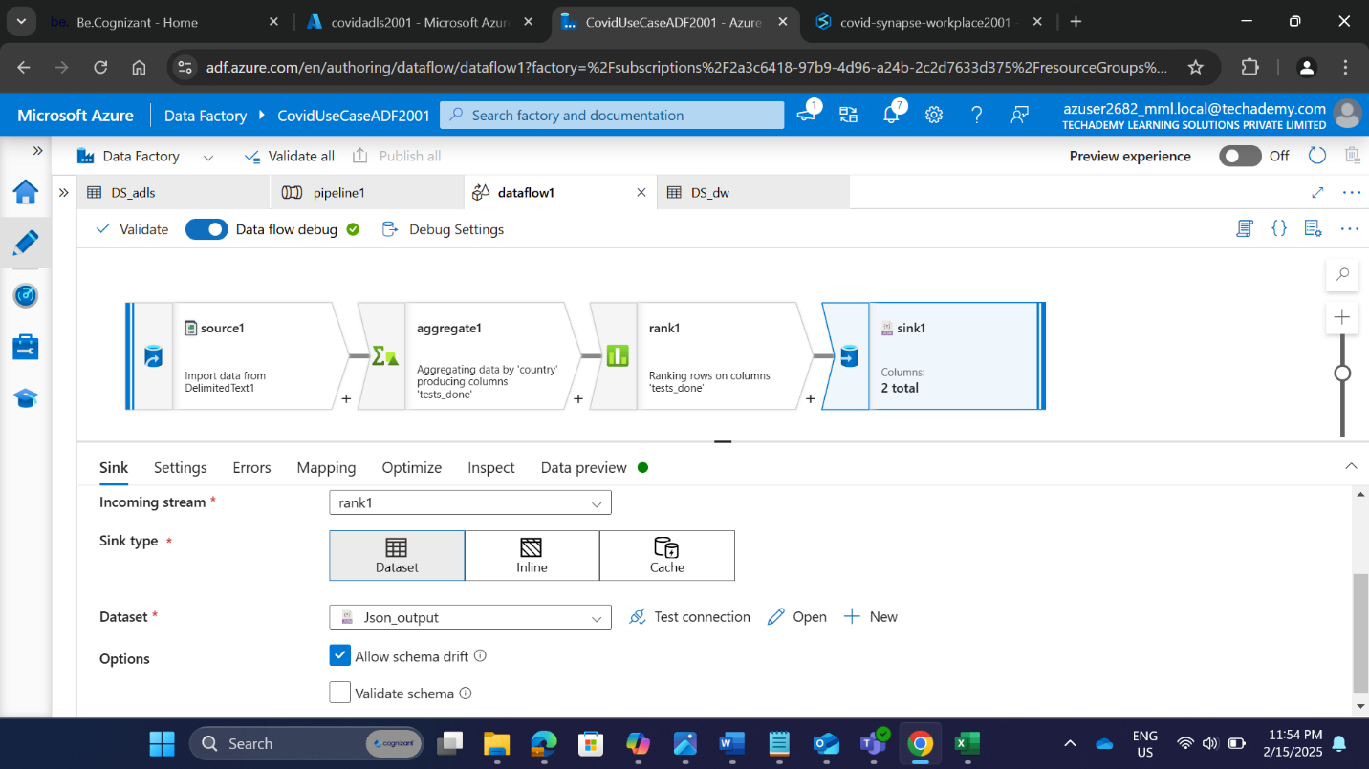

**FINAL PIPELINE  
  
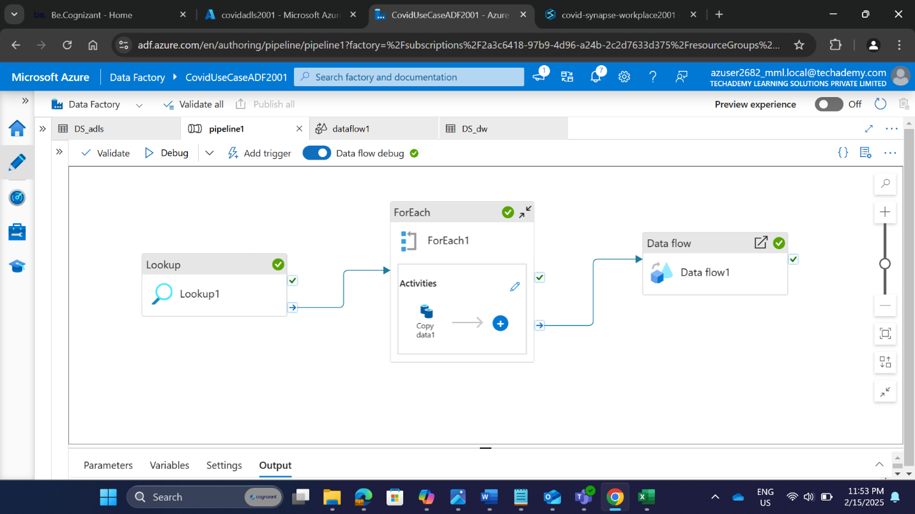**

* 1. **Data Warehouse and Transformation**

3.5.1 Understanding Synapse Tables Created

* Number of Tables Created: 5
* Table Names:
  + dbo. case_deaths_uk_ind_only
  + dbo. cases _deaths
  + dbo. country_response
  + dbo. hospital_admissions
  + dbo.testing
* Verification Queries Used:
  + SELECT * FROM dbo.hospital_admissions;
  + SELECT * FROM dbo.cases_deaths;
  + SELECT * FROM dbo.country_response;
  + SELECT * FROM dbo.case_deaths_uk_ind_only;
  + SELECT * FROM dbo.testing;

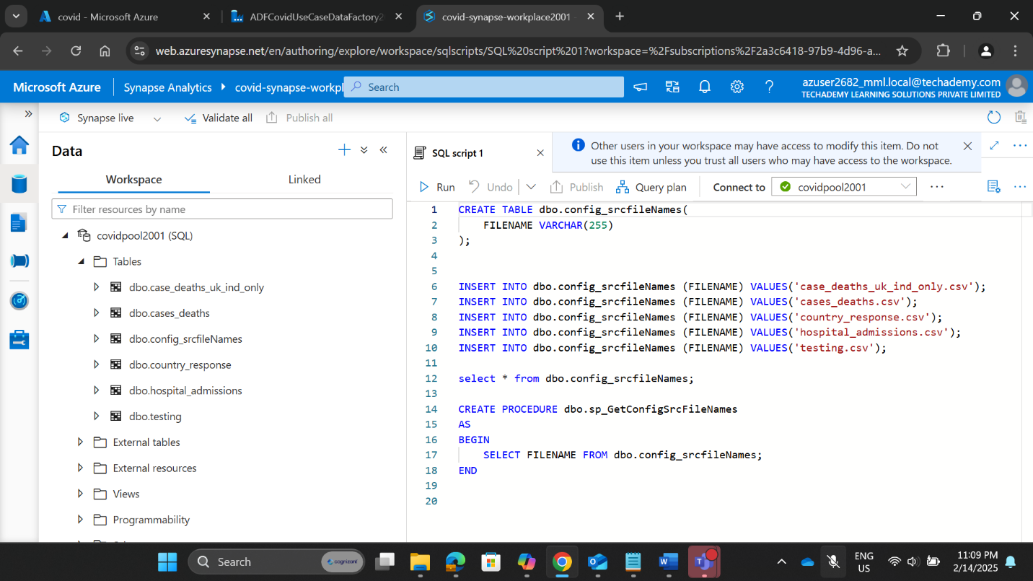

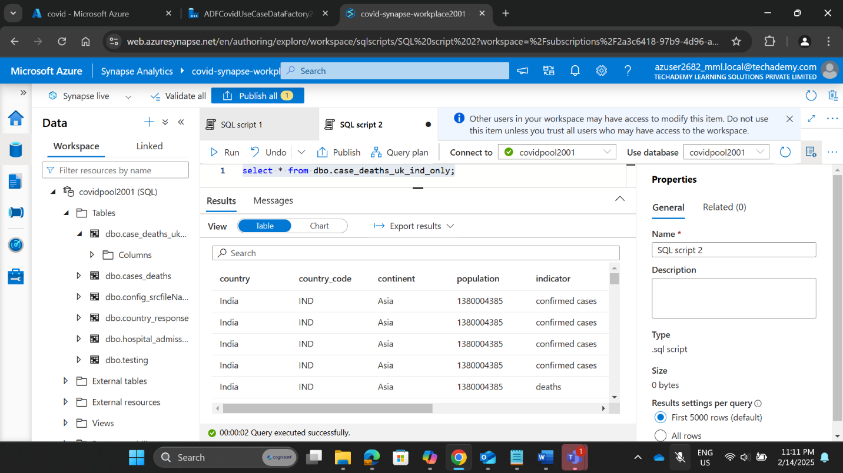

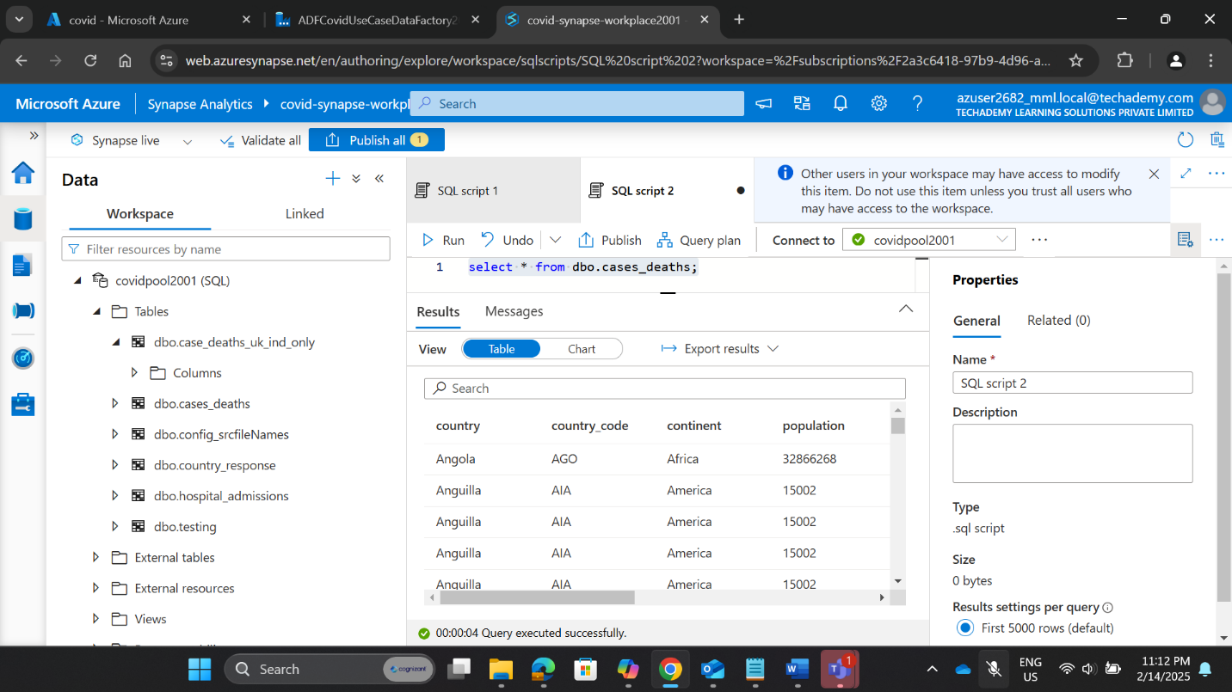

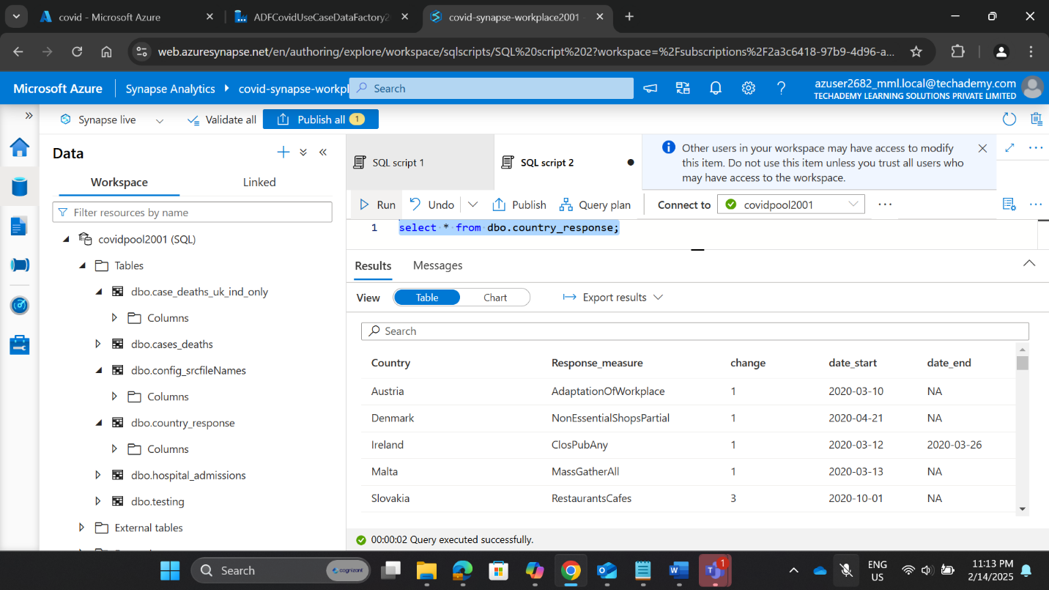

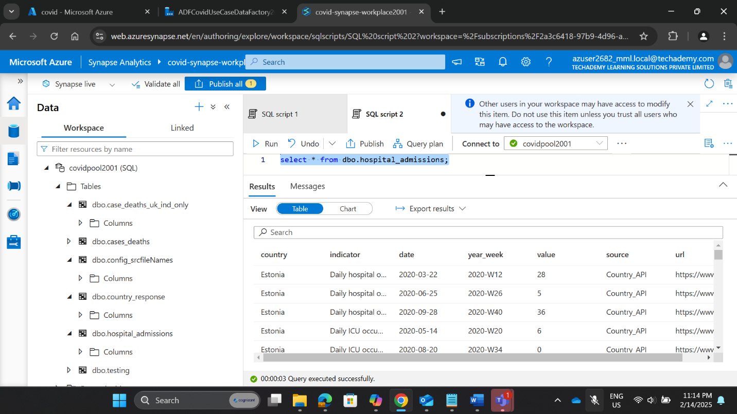

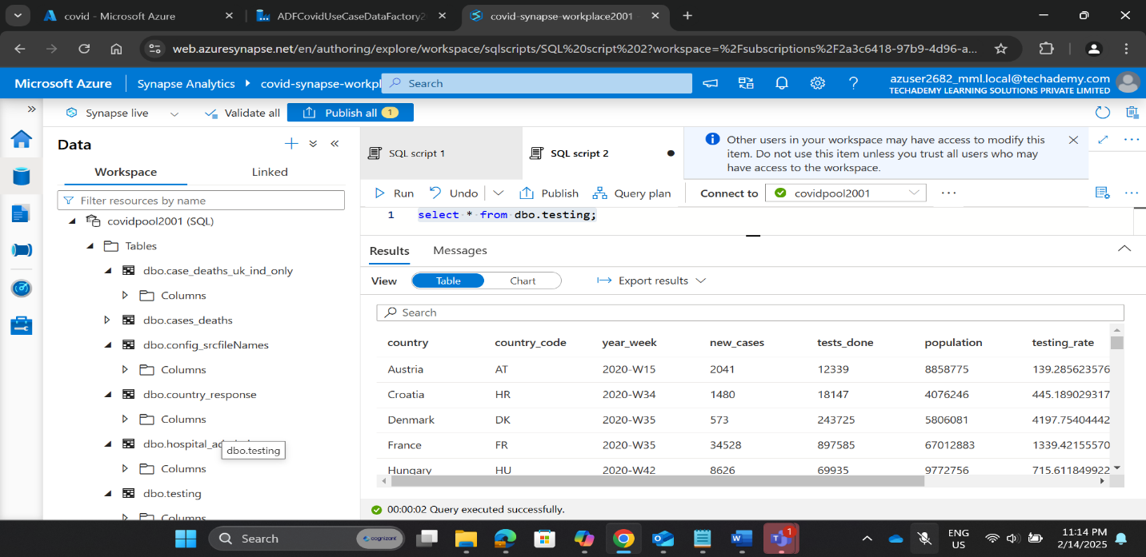

**3.6.2 Running SQL Queries for Data Validation**

* **SQL Query Used:**   
  + SELECT * FROM dbo.cases_deaths     
    WHERE indicator='deaths'     
    AND country=’Algeria'     
    AND (date BETWEEN '2020-04-01' AND '2020-04-31');
* **Verification with Source Data:** Matched

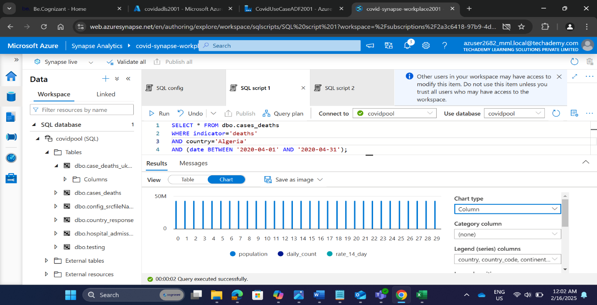

**4. Key Accomplishments**

* Successfully set up and configured Azure Data Lake Storage Gen2, Azure Synapse Analytics, and Azure Data Factory.
* Implemented an end-to-end data pipeline to process COVID-19 data.
* Created SQL configuration tables and stored procedures for automated data handling.
* Designed and executed queries to validate data accuracy and analyze COVID-19 trends.
* Automated the ingestion and transformation of multiple CSV files into Azure Synapse Analytics.

**5. Project Summary**Project: COVID-19 Data Pipeline in Azure Data Factory  
  
Objective: Designed and implemented a real-world data pipeline in Azure Data Factory (ADF) to analyze COVID-19 trends across different regions. The project covered data ingestion, transformation, and validation using:

* Azure Data Lake Storage Gen2
* Azure Synapse Analytics
* Azure Data Factory